UX Honeycomb Framework: A Guide to Wholesome User Experience
by Blessy Thampy
User Experience or UX, is the discipline that focuses on the complete experience a user has with a product. It goes beyond usability to encompass emotions, perceptions, and satisfaction throughout the user journey.
Peter Morville’s UX Honeycomb framework evaluates a product through its seven interconnected facets of user experience. As the name suggest, the honeycomb visually represents a structured system where each cell works closely with the other. Value flows from one cell to another, giving strength and coherence to the whole. No single element can be overlooked, as each contributes to a meaningful and holistic user experience.
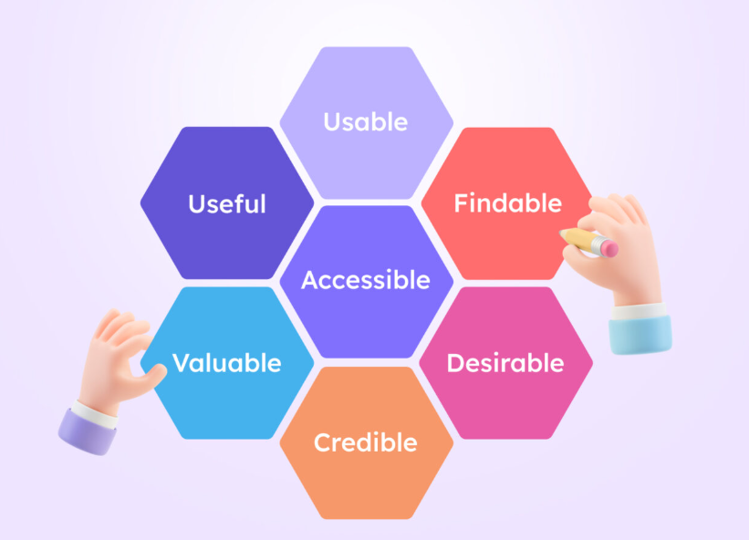

The Seven Embedded Cells
Usefulness - Usefulness refers to a product’s ability to solve genuine, real-world problems. Every feature should exist to fulfill a specific user need and contribute meaningful value.
Good usefulness, would mean:
- An e-commerce app like Amazon or Flipkart, the 'Order Tracking' solves the problem of uncertainty after purchase. Without this, the app would still function, but it would not be useful.
- In a Banking app, the ‘Transaction History’ and ‘Bill payments’ options assure us and proves its usefulness in terms of time saved and reduced stress.
Usability – Beyond usefulness, the product must be easy to use and navigate. In short user-friendly. A usable product enables the user to complete his task efficiently, without confusion or frustration.
Good usability:
- Clear navigation menus, familiar icons and labels, minimal steps to complete task.
- Too many clicks for simple actions, unclear error messages are examples of poor usability
Desirability – A well-designed interface - through visuals, micro-interactions, and tone—builds trust, engagement, and delight, making users want to return. Desirability focuses on the emotional response a product evokes.
Good desirability:
- High desirable design would use clean layouts with pleasing color palettes, thoughtful spacing and user-friendly messages.
- Low desirable designs would have clutters screens, dense colors, and cold, robotic messages.
Findability – User must be able to locate required content easily and immediately. Good findability keeps the users engaged and reduces unnecessary cognitive load by making information intuitive to discover.
Good findability:
- Websites with clear navigation menu (products, pricing, support)
- Well-structured headings, breadcrumbs on help page
Accessibility – This is a non-negotiable feature of an inclusive design. Products must be designed with diverse users in mind, users from different ethnic background and also those with physical, or cognitive challenges. An accessible interface ensures equal and seamless use for everyone.
Good accessibility:
- Alt text for images for screen readers
- High color contrast for visually impaired users
- Keyboard navigation without a mouse
Credibility – This is the core element for building user trust. A credible product would convey reliability, transparency, and professionalism, helping users to feel confident and secure while interacting with them.
High credibility:
- Secure payment badges and HTTPS lock icon
- Clear privacy policy and contact information
- Professional UI with consistent design
- Honest error messages and transparent pricing
Valuable – Ultimately, the product must deliver tangible benefits that justifies user’s investment of time and money. The experience should be rewarding to the customer. A valuable experience meets user needs effectively while creating lasting benefits for both the user and the business.
High value:
- A fitness app that shows measurable progress
- A learning app that improves job-ready skills
- A banking app that saves time through automation
Value is where user goals and business goals meet.
Conclusion
Peter Morville’s framework resonates with teams that aim to build products the users genuinely trust and love working with. When all the seven facets work in harmony, the result is a user experience that is intuitive, inclusive, and rewarding. By placing the user at the center of every design decision, it ensures that no aspect of the experience is overlooked. This holistic approach results in satisfied users who are confident, engaged, and eager to return whenever the need arises.
Credits:
https://www.visily.ai/blog/ux-honeycomb-seven-elements/
https://blog.logrocket.com/ux-design/applying-ux-honeycomb-modern-website/
https://en.wikipedia.org/wiki/User_experience

